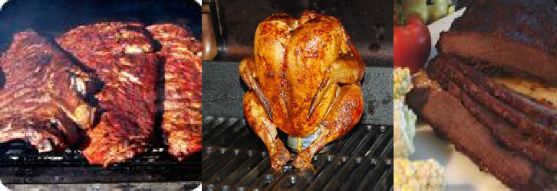

24th Annual Downtown Barbecue Cook-Off
(August 2, 2019, 12:00 p.m.-6:00 p.m.)
(August 3, 2019, 6:00 a.m.-6:00 p.m.)
Old Lowndes Courthouse Square, Downtown Valdosta, GA

Vendor (Non-Contestant) Registration Form (Please print clearly and legibly)

- Vendor Category VII. Method of Payment
Clothing check
Food money order

Household Items
Arts & Crafts
Other (specify)
cash

- Vending/Business Name

- Vendor’s Name or Person in Charge

- Mailing Address

Email Address

- Vendor’s Phone Number (including area code)

- General list of items you will sell _
_

- - - - - - - - - - - - - -- - - - - - - - - - - - - - -- - - - - - - - - - - - - - - - - - - - - - - - - - - - - - - - - - - - - - - - -
Cut along dotted line to divide and return top portion with your entry fee IMPORTANT INFORMATION FOR VENDORS
VENDOR FEE: $100.00. If vendor is selling meat items, the entry fee will be 250.00 instead of
$100.00. Call if you have any questions at all. Please make checks payable to 100 Black men of Valdosta, Inc. Deadline for registration is July 31, 2019. Note: After July 22, 2019, entry fee must be paid via cashier check, money order, or cash.

REGISTRATION: Mail the registration form and entry fee to:
100 Black Men of Valdosta, Inc.
P.O. Box 1352 Valdosta, GA 31603

DATE, TIME, & LOCATION:
Friday, August 2, 2019, 12:00 p.m. to 9:30 p.m. (Vendors can set up at 12:00 noon) Saturday, August 3, 2019, 6:00 a.m.-6:00 p.m. (Vendors can set up as early as 6:00 a.m.) Lowndes County Courthouse Square (Downtown Valdosta)

CHECK-IN INFORMATION:
Vendors may not begin setting up before 6:00 a.m. on Saturday morning. The assignment of spaces is determined by completion of registration process, to include payment of entry fee. Vendors who choose to set up on Friday can do so any time after 12:00 p.m.

QUESTIONS: If you have questions, please do not hesitate to call Lymas Johnson at (229) 251-1349 (cell). THANKS FOR YOUR SUPPORT!

Rules and Regulations – Vendors

  - No vendor may set up on Courthouse Square prior to 6:00 a.m. on the morning of the Cook-off event (Saturday). However, if vendors choose to setup on Friday, they cannot start setting up before 12:00 p.m. on Friday.

  - Vendor will be assigned to area (for setup) that is approximately 10’x10’. If food vendor, call me at my number below and let’s talk about your space requirements.
  - Vendor must provide their own table, chairs, etc.

  - Vendor can sell their product or services to the general public.

  - Vendor cannot sell or give away any liquid refreshments. NOTE: 100 Black Men of Valdosta has exclusive right to sale beverages (sodas, juices, water, etc.). Therefore, no vendors or cook-off contestants are allowed to sale these items.

  - Vendor must arrange all other items within their assigned spot so as to not damage the courthouse lawn or block the entire sidewalk.

  - Vendor must properly discard all trash and are responsible for clean-up and removal of all debris in and around their assigned spot.

  - Vendor is responsible for any and all damage caused to Lowndes County Courthouse property.
  - Vendor cannot move from assigned spot without expressed permission of the Barbeque Cook-off Coordinator.

  - Designed vendor spots are assigned to vendors as application and entry fees are received by 100 Black Men of Valdosta.

  - 100 Black Men of Valdosta has exclusive right to the sale of liquid beverages (sodas, juices, water, etc.). Therefore, no vendors or cook-off contestants are allowed to sale these items.

  - The 100 Black Men of Valdosta reserves the right to disqualify any vendor for rules violation.

NOTE: The 100 Black Men of Valdosta will have beverage wagons on both the Ashley and Patterson Street side of the Courthouse.

NOTE: If you have any questions please direct them to Lymas Johnson (229) 251-1349

